# Assignment 7 - Wireless Security

|  |
| --- |
| * This is an individual assignment and worth 20 points. * This is due at 2:30 (sec01) or 5:30 (sec76) on Tuesday, November 29. * Apply the usual naming convention. |

# Background

* This assignment is from National Cyber League (NCL) exercise. Use the attached “NCL-PCAP1.pcap”.
* You need to use Kali to answer the questions below. Send the attached pcap file to your email and download from Kali using Firefox. The file will be downloaded to the directory **/home/kali/Downloads**.
* Use **aircrack-ng** on Kali. Refer to the “CIS 480 Aircrack-ng.pptx” for ideas. You do not need to install aircrack-ng on Kali.
* You can find several websites that discuss “how to crack WEP with aircrack-ng.” For example, refer to: <https://null-byte.wonderhowto.com/how-to/hack-wi-fi-cracking-wep-passwords-with-aircrack-ng-0147340/>.

# Tasks

1. How many IVs are in the packet capture? Provide a screenshot that supports your answer. Run the following command: **aircrack-ng NCL-PCAP1.pcap**.

**Using command aircrack-ng /home/kali/Downloads/NCL-PCAP1.pcap, I found 14,337 IVs.**

1. What is the IV in the first packet in the capture (in hex)? Provide a screenshot that supports your answer.

**The IV in the first packet in the capture is the first row.**

1. What is the key (i.e., password input) you obtained after running aircrack-ng? Provide a screenshot that supports your answer.

**The key I obtained after running the command is listed below.**

1. What is the TCP checksum in the first packet of the capture (in hex)? Provide a screenshot that supports your answer. You must decrypt the capture with the key you obtained.

**The TCP checksum in the first packet of the capture is 0x9b27, highlighted below.**

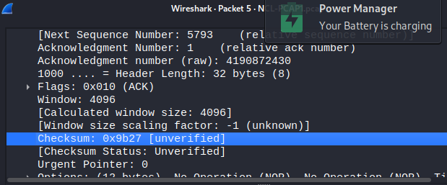

* How to decrypt the capture?
* Go to Wireshark > Edit > Preferences > IEEE 802.11 > …

